1. Power that is measured in volt-amperes is called? Answer: Apparent Power
2. What is The Reference Vector for parallel RC circuits? Answer: V
3. When Both series and Parallel RC impedance Decreases Which Component Increases? Answer: Frequency \* this question may have multiple answers
4. 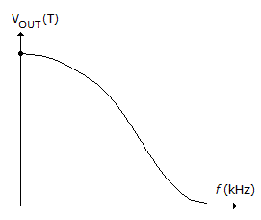The above Graph Represents Which Type of Filter? Answer: lpf
5. What is the effect of increasing the resistance in a series RC circuit? Answer: phase shift Decreases
6. Unit of flux Density? Answer: Tesla
7. What do you call the characteristic of a magnetic material whereby a change in magnetization lags the application of a magnetizing force? Answer: Hysteresis
8. Intrinsic semiconductor material is characterized by a valence shell of how many electrons? Answer: 4
9. Ionization within a P-N junction causes a layer on each side of the barrier called? Answer: Depletion Region
10. When and who discovered that more than one transistor could be constructed on a single piece of semiconductor material? Answer: 1959, Robert Noyce
11. Which type of PLD should be used to program basic logic functions? Answer: PAL
12. When does maximum power transfer happen from the source to the load? Answer: when Rs=Rl
13. The capacitor that produces an ac ground is called. Answer: Bypass Capacitor
14. A basic S-R flip-flop can be constructed by cross-coupling which basic logic gates? Answer: NOR and NAND
15. What is the significance of the J and K terminals on the J-K flip-flop? Answer: No significance